**Quiz 1**

**What does the knowledge base (KB) in AI consist of?**

1. **A set of sentences known by the knowledge-based agent**
2. A set of true and false values for each proposition
3. The set of all possible logical connectives
4. The set of all possible propositions

**How many models are generated for a knowledge base with 4 propositions?**

1. **16**
2. 32
3. 4
4. 8

**How does the Model Checking algorithm determine entailment?**

1. By using neural networks
2. By using fuzzy logic
3. **By comparing all possible models**
4. By generating random models

**What is knowledge engineering?**

1. **The process of representing propositions and logic in AI.**
2. The process of decoding encrypted messages.
3. The process of creating puzzles.
4. The process of designing game interfaces.

**Let propositional variable R be that "It is raining." the variable C be that "it is cloudy" and the variable S be that "It is sunny". Which of the following a propositional logic representation of the sentence "If it is raining, then it is cloudy and not sunny"?** **R→(C∧¬S)**.

**What is the primary goal of the Model Checking algorithm?**

1. **To determine if a given query is entailed by the knowledge base**
2. To generate all possible models for a given knowledge base
3. To find contradictions within the knowledge base
4. To evaluate the truth of every proposition in the knowledge base

**How can we define a sentence in a knowledge representation language?**

1. A representation of emotions
2. A hypothetical scenario
3. A question about the world
4. **An assertion about the world**

**What does entailment (⊨) imply?**

1. If one statement is true, another must be false
2. **If one statement is true, another must be true**
3. Logical equivalence
4. If one statement is false, another must be true

**What does implication (→) represent?**

1. A logical disjunction
2. **"If P then Q" structure**
3. A negation
4. A logical conjunction

**What does a truth table help us with?**

1. Measure the ambiguity of a sentence
2. **Compare all possible truth assignments to propositions**
3. Determine the length of a sentence
4. Classify sentences into categories

**What is the probability of rolling a sum of 12 with two dice?**

1. 1/6
2. **1/36**
3. 1/12
4. 1/18

**Which inference rule involves eliminating biconditionals by converting them into implications?**

1. **Biconditional Elimination**
2. Implication Elimination
3. Double Negation Elimination
4. And Elimination

**In the context of logical connectives, what does 'Not (¬)' represent?**

1. Logical conjunction
2. Logical disjunction
3. **Logical negation**
4. Logical equivalence

Quiz 2

**How many possible worlds are there when rolling a standard die?**

1. 1/6
2. 8
3. 4
4. 12
5. **6**

**In the example of rolling a die, what are the possible values for the random variable "Roll"?**

1. {0, 1, 2, 3, 4, 5, 6)
2. **{1, 2, 3, 4, 5, 6)**
3. {1, 2, 3}
4. {0, 1, 2, 3}

**How is negation (P(¬a)) related to probability?**

1. **P(¬a) = 1 - P(a)**
2. P(¬a) = 1 / P(a)
3. P(¬a) = 2 - P(a)
4. P(¬a) = P(a)

**What does P(A | B) represent in conditional probability?**

1. Probability of either event A or event B occurring
2. Probability of both events A and B occurring simultaneously
3. Probability of event B occurring given event A has occurred
4. **Probability of event A occurring given event B has occurred**

**What is the definition of Unconditional Probability ?**

1. **It is the degree of belief in a proposition in the absence of any other evidence.**
2. It is the degree of belief in a proposition given some evidence that has already been revealed.
3. Еach of the above
4. It is the likelihood of multiple events all occurring.
5. None of the above

**What is the probability of rolling a 7 when rolling two dice?** **6/36 = 1/6**

**Imagine flipping two fair coins, where each coin has a Heads side and a Tails side, with Heads coming up 50% of the time and Tails coming up 50% of the time. What is the probability that after flipping those two coins, one of them lands heads and the other lands tails?**

1. 0.875
2. 0.125
3. 1
4. **0.5**
5. 0.25
6. 0
7. 0.625
8. 0.75
9. 0.375

**What is the role of an arrow in a Bayesian network?**

1. It represents a joint probability
2. **It shows a causal relationship**
3. It indicates a marginal probability
4. It signifies a conditional probability

**What does a Bayesian network consist of?**

1. **Random variables and their conditional probability distributions**
2. Disjoint nodes
3. Independent nodes
4. Joint probability distributions

**What is the definition of Joint Probability?**

1. Each of the above.
2. **It is the likelihood of multiple events all occurring.**
3. It is the degree of belief in a proposition given some evidence that has already been revealed.
4. None of the above.
5. It is the degree of belief in a proposition in the absence of any other evidence.

**What is the range of values for conditional probability?**

1. **0 to 1**
2. -∞ to ∞
3. -1 to 1
4. 0 to ∞

**What is a random variable in probability theory?**

1. A variable with an infinite domain of possible values
2. **A variable with a fixed domain of possible values**
3. A variable with an uncertain domain of possible values
4. A variable with a single possible value

**What is unconditional probability in AI?**

1. Probability with partial knowledge
2. Probability of a specific event
3. **Probability in the absence of any evidence**
4. Probability dependent on previous events

**Bayes’ rule is commonly used in probability theory to compute conditional probability. It the formula correct? P(b|a) =P(a|b)/P(a)P(b)** **Неистина**

**Bayes’ rule is commonly used in probability theory to compute conditional probability. It the formula correct? P(b|a) = P(b)P(a|b)/P(a) Истина**

**What is the explanation of the formula P(a ∨ b) = P(a) + P(b) - P(a ∧ b)**

1. This stems from the fact that the sum of the probabilities of all the possible worlds is 1, and the complementary literals a and ¬a include all the possible worlds.
2. The probability of event a occurring is equal to the probability of a given b times the probability of b, plus the probability of a given ¬b time the probability of ¬b.
3. **This can interpreted in the following way: the worlds in which a or b are true are equal to all the worlds where a is true, plus the worlds where b is true. However, in this case, some worlds are counted twice (the worlds where both a and b are true).**
4. The idea here is that b and ¬b are disjoint probabilities. That is, the probability of b and ¬b occurring at the same time is 0. We also know b and ¬b sum up to 1.

**What is the explanation of the formula P(a) = P(a | b)P(b) + P(a | ¬b)P(¬b) ?**

1. This stems from the fact that the sum of the probabilities of all the possible worlds is 1, and the complementary literals a and ¬a include all the possible worlds.
2. The idea here is that b and ¬b are disjoint probabilities. That is, the probability of b and ¬b occurring at the same time is 0. We also know b and ¬b sum up to 1.
3. This can interpreted in the following way: the worlds in which a or b are true are equal to all the worlds where a is true, plus the worlds where b is true. However, in this case, some worlds are counted twice (the worlds where both a and b are true).
4. **The probability of event a occurring is equal to the probability of a given b times the probability of b, plus the probability of a given ¬b time the probability of ¬b.**

**What is the explanation of the formula P(a)=P(a,b)+P(a,¬b)?**

1. This follows from the fact that the sum of the probabilities of all possible worlds is 1, and the complementary literals a and ¬a include all possible worlds.
2. **The idea is that b and ¬b are incompatible probabilities. The probability that b and ¬b occur simultaneously is 0. Also b and ¬b add up to 1.**
3. The probability of event a is equal to the probability of a at b times the probability of b plus the probability of a at ¬b times the probability of ¬b.
4. This can be interpreted as follows: the worlds where a or b is true are equal to all the worlds where a is true plus the worlds where b is true. In this case, some worlds count twice.

**How is independence defined mathematically for events a and b?**

1. P(a) - P(b) = P(a ∩ b)
2. P(a) / P(b) = P(a ∩ b)
3. **P(a)P(b) = P(a ∩ b)**
4. P(a) + P(b) = P(a ∩ b)

**Which of the following statements is true?**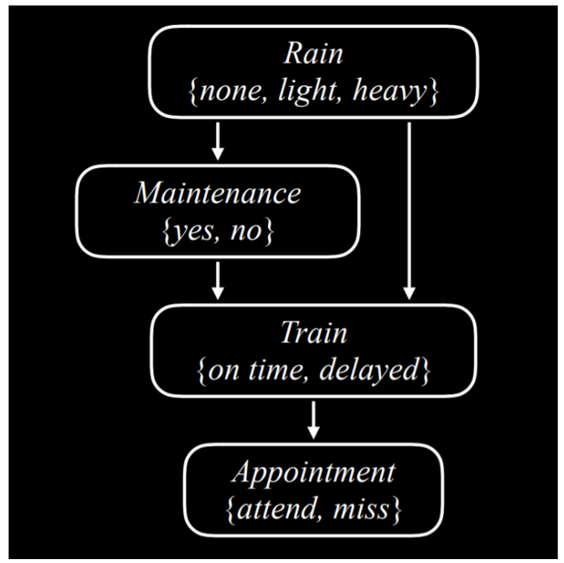

1. Assuming we know the train is on time, whether or not there is rain affects the probability that the appointment is attended.
2. Assuming we know there is rain, whether or not there is track maintenance does not affect the probability that the train is on time.
3. **Assuming we know there is track maintenance, whether or not there is rain does not affect the probability that the train is on time.**
4. Assuming we know the train is on time, whether or not there is track maintenance does not affect the probability that the appointment is attended.
5. Assuming we know there is track maintenance, whether or not there is rain does not affect the probability that the appointment is attended.

Za QUIZ 3 vuprosi s tezi:

**A juice stand sells two types of fresh juice in 12 oz cups, the Refresher and the Super-Duper. The Refresher is made from 3 oranges, 2 apples and a slice of ginger. The Super Duper is made from one slice of watermelon, 3 apples and one orange. The owners of the juice stand have 50 oranges, 40 apples, 10 slices of watermelon and 15 slices of ginger. Let x denote the number of Refreshers they make and let y denote the number of Super Dupers they make. Now suppose that Refreshers sell for $12 each and Super-Dupers sell for $18 each. If a goal of the juice stand is to maximize revenue, then they want to maximize the value of objective function, given the constraints on production.**

1. the objective function is: 50х +40у
2. **the objective function is: 12х +18у**
3. the objective function is: 2х +3у
4. the objective function is: 3х +у

* **Steepest-ascent:** choose the highest-valued neighbor
* **Stochastic:** choose randomly from higher-valued neighbors
* **First-choice:** choose the first higher-valued neighbor.
* **Random-restart:** conduct hill climbing multiple times. Each time, start from a random state
* **Local Beam Search:** chooses the k highest-valued neighbors

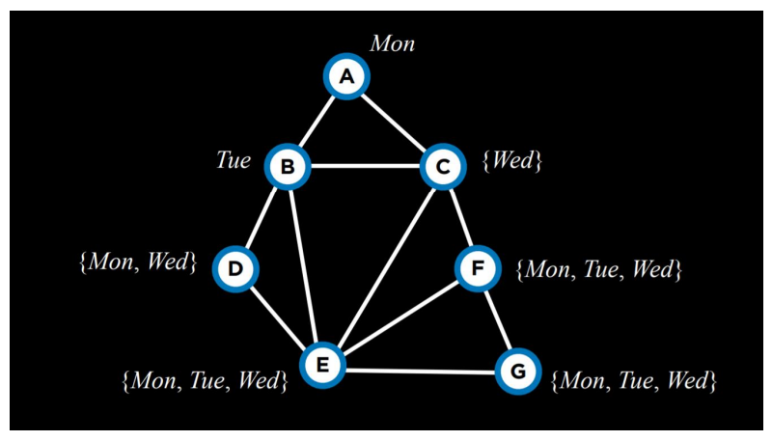

tui ama s razmeneni stoinosti

**The following pseudocode explains the Simulated-Annealing algorithm.What is the purpose of the function T = Temperature(t)**

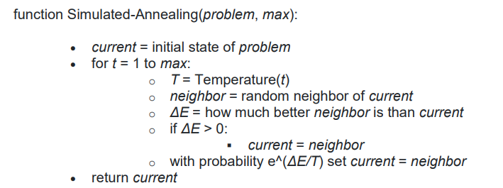

1. None of the above
2. The smaller the input argument, the larger the output.
3. The return value correspond of probability for choose better neighbor state.
4. **The larger the input argument, the smaller the output.**

QUIZ 4

**Does Unsupervised Learning require labeled or unlabeled data?**

1. labelled
2. **unlabelled**

**When you find noise in data which of the following option would you consider in k-NN?**

1. None of these
2. Noise can not be dependent on value of k
3. **I will increase the value of k**
4. I will decrease the value of k

**Imagine a regression AI that makes the following predictions for the following 5 data points. What is the total L2 loss across all of these data points(i.e., the sum of the individual L2 losses for each data point)?**

**For data point 1 , the true output is 2 and the AI predicted 4. For data point 2, the true output is 1 and the AI predicted 2. For data point 3 , the true output is 3 and the AI predicted 4. For data point 4, the true output is 3 and the AI predicted 6. For data point 5, the true output is 2 and the AI predicted 4.**

1. 19
2. 81
3. 0
4. **9**

**If we apply Perceptron Learning to a classification problem. What should the threshold function be if the results are to exclude uncertainty.**

1. **Hard threshold**
2. Hard threshold after that Soft threshold
3. None of them
4. All of them
5. Soft threshold

**Which of the following step / assumption in regression modeling impacts the trade-off between under-fitting and over-fitting the most.**

1. The use of a constant-term
2. Whether we learn the weights by matrix inversion or gradient descent
3. **The polynomial degree**

**What is the role of a 'reward' in reinforcement learning?**

1. To provide data for supervised learning
2. **To give feedback to the agent about the quality of its actions**
3. To structure the learning environment
4. To predict the next state of the environment

**Which of these is an example of a supervised learning task?**

1. Clustering
2. Association rule learning
3. **Image classification**
4. Principal component analysis

**In Supervised Learning, what types of Classification are there?**

1. **Binary classification**
2. n-gram classification
3. Binning
4. **Multi-class classification**

**What is the main objective of a Support Vector Machine?**

1. To cluster data into groups
2. **To find a hyperplane that best divides a dataset into classes**
3. To predict numerical values
4. To reduce the dimensionality of the data

**In unsupervised learning, what does 'anomaly detection' refer to?**

1. **Finding patterns that do not conform to expected behavior**
2. Predicting future values based on historical data
3. Classifying data into predefined categories
4. Enhancing the features of a dataset